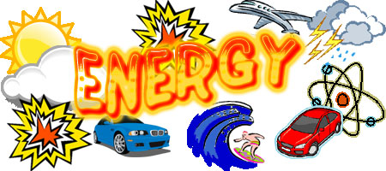
Energy Demands
Using the Pearson Science 7 Student Book p.80 - 81answer the following questions:
1. How were early humans energy needs met? _____________________________
_____________________________________________________________________
(1 mark)

2. List some objects we have today that require a lot of energy to manufacture and use __________________________________________________________________
_____________________________________________________________________
(2 marks)

3. Using Figure 3.2.1. How does the energy requirements of a primitive society compare to a hunting society? _____________________________________________
__________________________________________________________________________________________________________________________________________
(2 marks)

4. How does a primitive society compare to today’s Western Technological Society? ______________________________________________________________
__________________________________________________________________________________________________________________________________________
_____________________________________________________________________
(2 marks)

5. Using the data in Table 3.2.1. Graph the Energy use per person as a column graph.
(5 marks)

6. List the three countries with the highest energy use per person ______________
_____________________________________________________________________
(1 mark)

7. Why do you think the energy usage per person is so high in Australia, Canada and the US? ___________________________________________________________
_____________________________________________________________________
_____________________________________________________________________
(2 marks)

8. List the three countries with the lowest energy use per person ______________
_____________________________________________________________________
(1 mark)

9. Why do you think these three countries might have a low energy use per person? ______________________________________________________________
_____________________________________________________________________
_____________________________________________________________________
(2 marks)

10. How do think a fast developing country, like China, may rate in a few year? _____________________________________________________________________
_____________________________________________________________________
_____________________________________________________________________
(2 marks)

11. What do you think might be some of the consequences to the environment of such high energy demands? ______________________________________________
_____________________________________________________________________
_____________________________________________________________________
_____________________________________________________________________
_____________________________________________________________________
_____________________________________________________________________
(2 marks)


